## 5-15 pages

## IntroductionOur goal in this project was to apply AI techniques and database knowledge acquired during the semester to develop an application capable of handling basic queries for both SQL and NoSQL databases. The application can translate natural language requests into executable queries, perform real-time updates, and present database details to the user.

Throughout the project, we reinforced our understanding of database querying, front-end and back-end development, and learned how to integrate AI techniques into data analytics applications.

## 

## Planned Implementation (From Project Proposal)(Rongzi Xie)

### AI Chatbot

We planned to use free & open source text generation models to convert user’s queries to SQL or Nosql commands. For now, one of our options is to use python to implement the Meta Llama model, and we also found some useful resources to help us complete the implementation:<https://github.com/abetlen/llama-cpp-python>.

Due to the limitation of hardware, we also consider small and fast models, converting the user's query shouldn’t be difficult for AI agents, and here are some small models we found from hugging face that might be useful.

We consider the new DeepSeek & Llama AI model.

<https://huggingface.co/deepseek-ai/DeepSeek-R1-Distill-Llama-70B>

Also, Mistral models seems to be extremely small but outperforms other model in many tests, so we also consider using this one:<https://mistral.ai/en/news/announcing-mistral-7b>

We want to compare the performance of each model based on their difficulty level of implementation, ability to convert user queries and efficiency. At last we chose the deepseek model due to its cheap price and extraordinary understanding of natural languages.

### SQL&NoSQL Database Exploration and Operation

Our AI chatbot needs to convert natural language into database queries, so the choice of database should depend on the type of data to be stored and queried, so far according to the lookup, MongoDB, Hadoop, and Spark may be the potential databases we will select

Meanwhile, we also learned that a vector database called Pinecone is mainly used for similarity search, embedded search, and large-scale AI applications, and can provide low-latency, high-performance vector retrieval. It can improve the performance of our chatbot in the direction of semantic query enhancement, storing and optimizing query history, and natural language to SQL conversion optimization.

* Database Construction: choose MySQL or MongoDB, choose whether to introduce Pinecone for vector data processing, and design the data table/document structure.
* Develop Backend API: Create/query interface using django paths, and return SQL/NoSQL queries. Also, explore whether using the Pinecone database can improve the accuracy and speed of responses.
* Integrate AI Models: Implement natural language to SQL conversion with DeepSeek.
* Build Links to Front-end Pages: Design links to front-end pages and implement features required by front-end pages. Implement login page, SQL query page and non-SQL query page
* Deployment and Optimization: Containerization with Docker, Redis caching of queries, monitoring database performance.

### Frontend UI Design

We plan to design a frontend page similar to the ChatGPT style, aiming to create a clean, user-friendly, and highly interactive interface.

For the main search area, we intend to design a large text input field where users can enter natural language queries. The input field will be simple, clear, and always visible, with placeholder text such as "Ask me about information in the database..." to guide users and encourage them to ask questions or give commands. When clicked, these buttons will open a brief form where users can fill in the relevant data. An example is shown below.

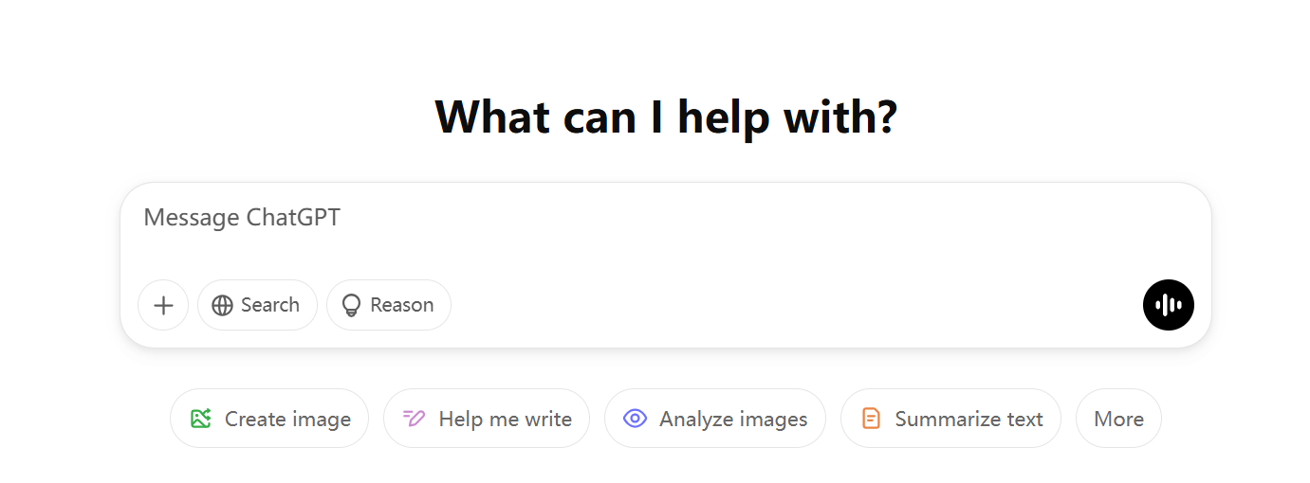

Each query and its response will be displayed in a table like format, clearly distinguishing between user input and system responses. To enhance interactivity with users, we plan to design dynamic responses. When users enter queries, the interface will display a "loading" message to inform users that the system is processing the query. After the query is entered, the system will immediately process the natural language and display the results. If there is an error or any issues with the query, the system will provide clear and friendly error messages, similar to ChatGPT’s error prompts, allowing users to correct the query. If the query results are too long, the chat window should smoothly scroll, and users can click to load more results, similar to how ChatGPT loads more messages.

### Test

We plan to implement some real world dataset that has connections to each other to test our model’s performance on join, search, updating, deletion and other common database query,

We planned to use a database from our homework and lab, which surely meet the requirements.

## Architecture Design (Flow Diagram and its description) （Yihao）

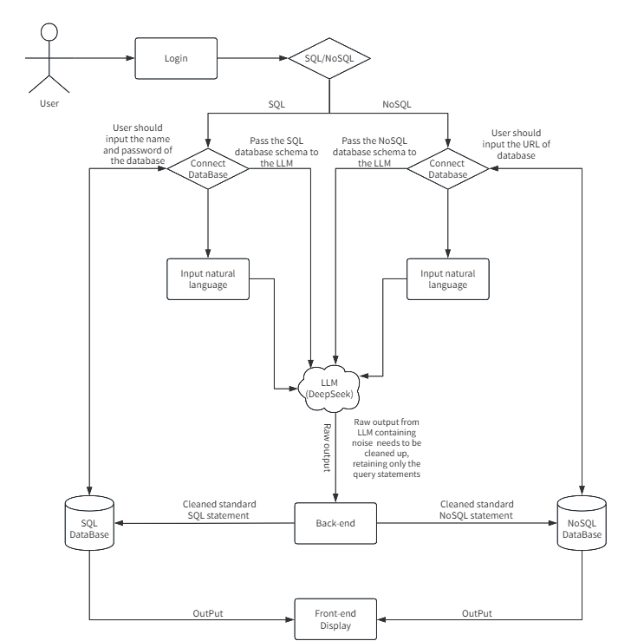

## Implementation(一人一个)

### 1. Functionalities（）

Front End-UI:

Front End-UX:

Back End-query Conversion:

Back End-error handling:

### 2. Tech Stack（）

Application Structure

DSCI551_PROJECT/

├─ dsci551_project/

│ ├─ __init__.py

│ ├─ asgi.py

│ ├─ settings.py

│ ├─ urls.py

│ ├─ wsgi.py

│ └─ manage.py

└─ dsci551/

├─ migrations/

├─ static/

│ └─ images/

│ └─ logo.png

├─ templates/

│ ├─ login.html

│ ├─ register.html

│ ├─ select_database.html

│ ├─ query_form.html

│ ├─ query_history.html

│ ├─ nosql_query.html

│ └─ dj_home.html

├─ __init__.py

├─ admin.py

├─ apps.py

├─ models.py

├─ tests.py

└─ views.py

Package Used

Django==5.0.3

pymongo==4.12.1

PyMySQL==1.1.0

Requests==2.32.3

Front End

Templating: Django Templates (HTML5, CSS3, JavaScript)

Back End

Framework: Django (optionally with Django REST Framework)

ORM: MySQL via Django ORM, MongoDB via PyMongo

LLM Integration: DeepSeek API

Error Handling:

Catch and report LLM timeouts or failures

Handle database execution errors with clear JSON error responses

### 3. Implementation Screenshots (Few not all)（Rongzi Xie）



Run the above code under dsci551_project, and wait for the server to be started

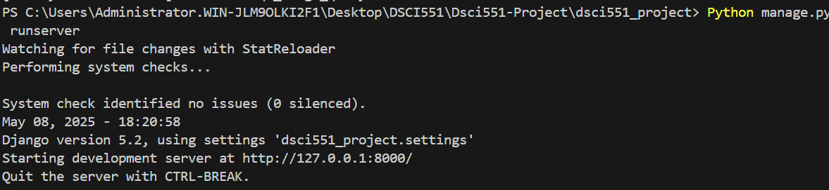

Click to the localhost link to access our application

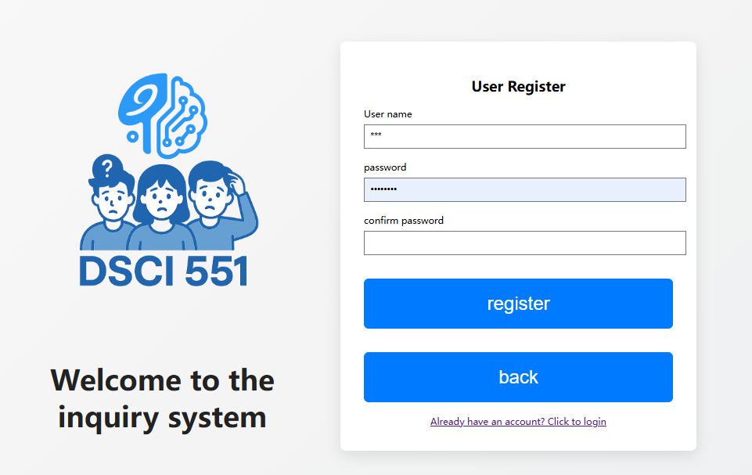

After registration, log in with your username and password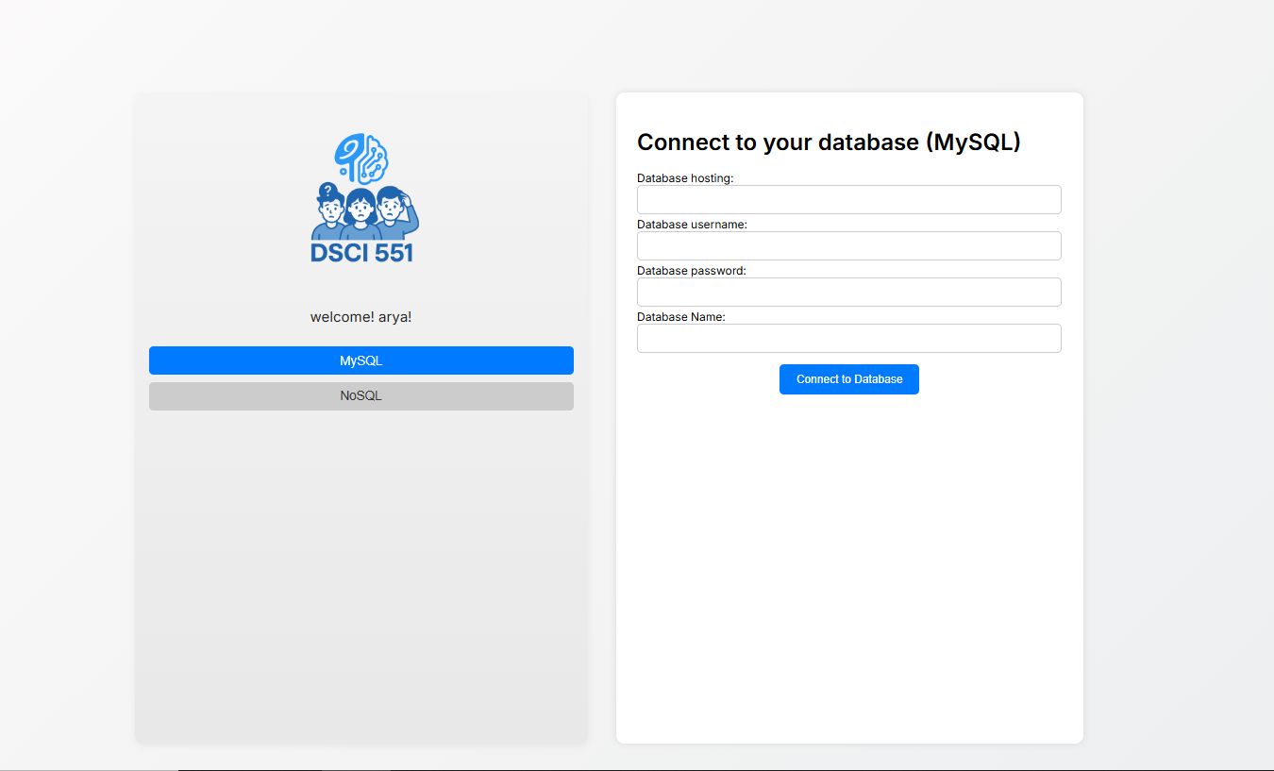

For the SQL part, make sure you enter the correct username and password before clicking the connect to database button

## 

After that you can enter your query.

## 

Same thing for the mongoDB part, please enter the link and your database name, separated by a comma. For example: “mongodb://localhost:27017/,dsci551”, and make sure there is nothing else, no empty space and newline character

During the process, please do not hit the website’s back and forward button on the upper left, please use our “back” and “logout” button to go back to the last page.

## Learning Outcomes

1. Front-end design:(Yixiu Wang)
2. AI chatbot(Yihao Wang):

The AI chatbot is the most critical component of our project, as it determines whether query conversion succeeds. Through this process, we learned how to integrate a large language model (LLM) into our application using API keys and how to guide it with customized prompts to perform specific tasks.

One of the most valuable takeaways was learning how to craft effective prompts that provide the AI with just enough database context to complete tasks—especially when working with a limited version of the model due to budget constraints. Unlike using full-featured models through platforms like ChatGPT or DeepSeek, we had to be extremely concise and precise in our instructions to avoid unnecessary output and ensure the AI returned clean, executable code.

At times, the AI produced incorrect results or even refused to generate code, which required continuous refinement of our prompts to achieve the reliability and consistency we needed.

1. Sql and nosql(Rongzi Xie)

We learned how to craft effective prompts to guide the chatbot in establishing connections to databases and enabling generative AI to understand database structures. Throughout this process, we deepened our understanding of database architecture, along with tools such as PyMongo, PySQL, and SQLAlchemy.

In the early stages of the project, we used Django to connect to an SQL database. However, we eventually decided to embed database connectivity directly into the application’s functionality. This allows users to connect to their own databases and work with any dataset they choose. Our system, chatDB, dynamically interprets the structure of the connected dataset and generates appropriate responses.

While this design significantly increased the complexity of the project—and introduced the risk of AI instability—we carefully structured our code to ensure robust database connections, accurate parsing of dataset schemas for the AI, and well-defined prompts that guide the AI in executing the correct query logic.

For error handling, we also learned to distinguish between different output types from SQL and NoSQL queries and developed separate handling strategies for each.

## Challenges Faced（Rongzi Xie）

Connections to Database:

Initially, connecting to an SQL database created a lot of confusion. We had to modify Django settings to ensure it connected to our local databases, and each time a team member pulled the code from GitHub, they had to manually update the username and password in the settings to run the application. We quickly realized this approach was not practical for real users, who shouldn't be expected to edit the codebase. To solve this, we switched to using PySQL and PyMongo for database connections and added a front-end interface where users can input their own database credentials. This made the system far more user-friendly and flexible.

AI’s Instability:

Since we wanted our AI to support arbitrary databases, it needed to be robust across different data types without relying on prompts tailored to a specific database. Initially, we let the AI infer everything on its own, but the results were poor. The AI often ignored instructions to learn the database structure and started hallucinating tables or fields that didn’t exist—an issue common with large language models.

To address this, we wrote code to automatically extract the actual database schema, including table names, column names, and indexes. This structured information is then passed to the AI as context, allowing it to generate more accurate queries. We found that SQL databases produced more stable results, while MongoDB (NoSQL) posed greater challenges due to its flexible and nested data structures. As a result, we had to design more detailed and precise prompts when working with MongoDB to avoid errors.

Integrity of Application Structure:

As a three-person team with each member responsible for different components—frontend, SQL, and NoSQL—miscommunication occasionally led to confusion about the application's current version, integration between the frontend and backend, and discrepancies between GitHub branches. At times, an accidental push of an outdated or incompatible version disrupted the entire system.

However, through a month of collaboration, communication, and iteration, we developed effective strategies to stay aligned. Frequent check-ins, clear documentation, and consistent confirmation after each pull, push, and code update helped us maintain synchronization across the project. This experience greatly improved our teamwork and taught us the importance of coordination in collaborative development.

## Individual Contribution (for multi-person team)（每个人写自己的）

### Yihao Wang: In charge of transforming user natural-language queries into optimized MySQL statements, and integrating the large-language-model interface to enable seamless end-to-end query execution and result retrieval.

### Yixiu Wang

Rongzi Xie: In charge of homework submission, meeting arrangement and handling coding part of converting natural language to mongoDB query.

## (conclusion 和future: Yixiu Wang)

## Conclusion

## Future Scope

There were a few features we believed would significantly improve user experience but were not completed due to time constraints:

1. Query History:

Adding a feature to store users’ query history would allow them to review previous outputs, reducing the need to repeat questions to the chatbot. It would also help users better understand their interactions with the dataset, including tracking operations like updates or deletions—offering insight into how the dataset has changed over time.

1. Firebase Query Support:

As part of our goal to support NoSQL databases, we planned to implement natural language query conversion for Firebase by translating user input into cURL-based queries. While we began testing this functionality, we were unable to complete the implementation and validation process.

1. Mobile-Friendly Frontend:

Our application is web-based and currently optimized for desktop screens. While the front-end design works well on computers, it may be less convenient on mobile devices—especially due to the sidebar navigation for selecting SQL or NoSQL query modes. In the future, adapting the layout responsively for mobile screens would greatly enhance usability and accessibility across different devices.